Ideation Phase
Define the Problem Statements

Date | 01 January 2026
Team ID | 4967
Project Name | Shopez
Maximum Marks | 2 Marks

Customer Problem Statement Template:
To define the core problems book lovers face while searching for and buying books online, and use those insights to guide the development of Indian Bookstore.

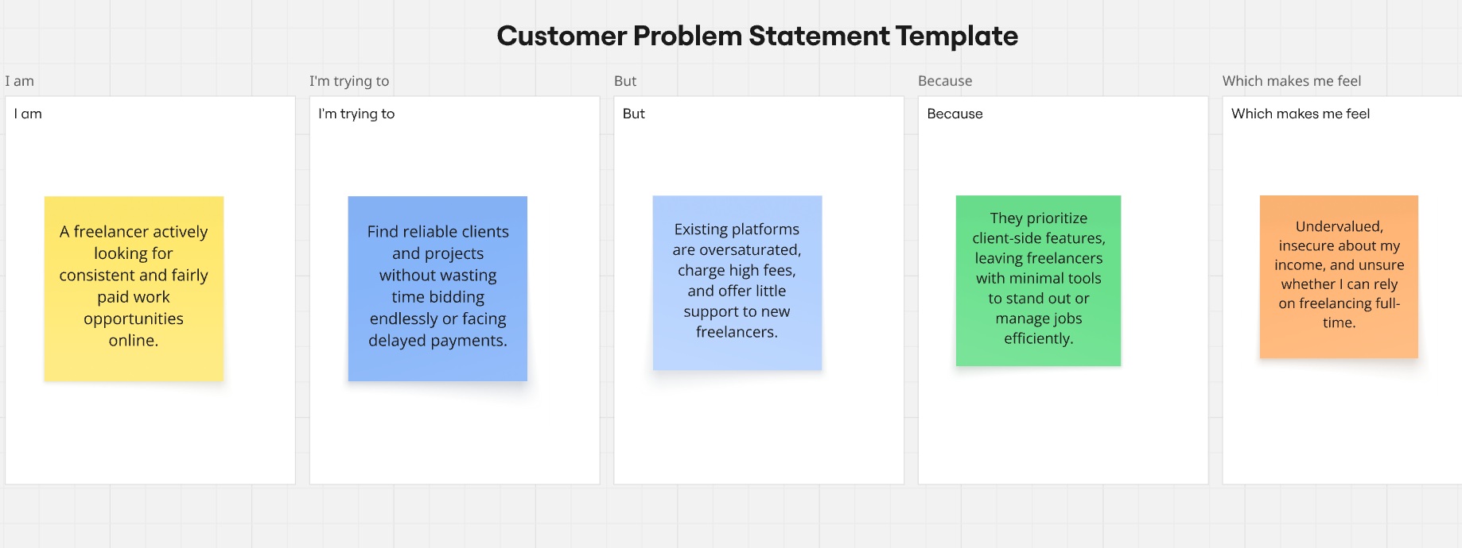
Reference: https://miro.com/templates/customer-problem-statement/

Problem Statement (PS) | I am (Customer) | I’m trying to | But | Because | Which makes me feel
PS-1 | an online shopper in India | buy products like shoes and phones at good prices | most sites have poor search, bad images, or cart issues | it's hard to find and trust products quickly | frustrated and hesitant.
PS-2 | a frequent buyer | manage my cart and see total easily | many sites have buggy cart or no quantity control | I lose items or get surprised at checkout | annoyed and disorganized.

